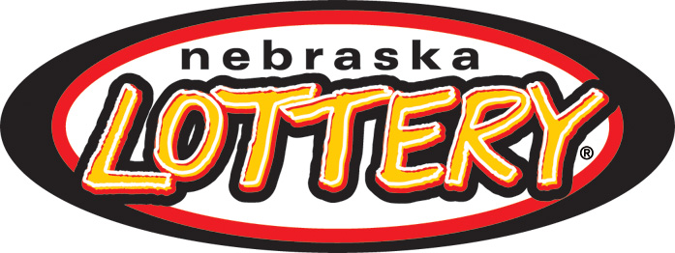

PowerballMillionaires

As of August 2016

# $1 Million Powerball Winners since Jan. 2012

1. Christopher Braun, Omaha (group of 16 players) – February 2012
2. Marcella Stoller, Omaha – October 2012
3. Barbara Maas, Hoskins – October 2012
4. Crystal Slaughter, Omaha – April 2012
5. Roger Cook, Lincoln – May 2013
6. Darold Kempston, Dorchester – June 2013
7. Thomas Reiners, Omaha – August 2013
8. Dustin Wood, Lincoln – September 2013
9. Patricia Krontz, Homer – October 2013
10. Jerry Wells, Lincoln – November 2013
11. Carpe Diem, L.L.C., Kearney – December 2013
12. Marty McElrath, Omaha – December 2014
13. Martha Poage, Scottsdale, AZ – June 2015
14. Randy Houpt, North Platte – September 2015
15. “The Lucky 32” lottery group – Lincoln – January 2016
16. Winner TBA – ticket sold at Cubby's, 15625 Cm Hadan Dr., Bennington – July 2016

# $2 Million Powerball with Power Play Winners since Jan. 2012

1. Mark Davies, Bennington – August 2012
2. Lonnie White, Seward – May 2013
3. Gary Kouma, Raymond – November 2015

*Players who choose to add the $1 Power Play option have the chance to play for enhanced prizes. The Match 5 Powerball Prize is $2 million with the Power Play option selected. See* [*http://www.nelottery.com/homeapp/lotto/28/gamedetail*](http://www.nelottery.com/powerball.xsp) *for more information.*

# Nebraska Powerball Jackpot Winners

1. Lyle and Dianne Fleharty of Hastings, $50.1 million, July 30, 1994
2. Connie Daily of North Platte, $50.5 million (split $101 million with an Indiana winner), November 30, 1994
3. Donald and Rita Polak of Prague, $8.1 million on April 19, 1995
4. Greg Klein of Milford, $2.5 million (split $5 million with an Indiana winner), April 24, 1996
5. Richard and Iris Johnson of Ayr, $18.5 million (cash option on $33 million), November 28, 1998
6. Marilyn and Charles Anderson of North Platte, $2.54 million (cash option on $10 million split with a Kentucky winner), November 3, 1999
7. Shirley Brewer of Omaha, $7.5 million (cash option on $14 million), August 26, 2000
8. Steven Herber of Omaha, $5.6 million (three-way split of $30 million, $16.5 million cash option), December 22, 2004
9. Quang Dao, David Gehle, Alain Maboussou, Chasity Rutjens, Robert Stewart, Michael Terpstra, Dung Tran, and Eric Zornes of Lincoln, $177.3 million (cash option on $365 million), February 18, 2006
10. David and Erica Harrig of Gretna, $34.1 million (cash option on $122.9 million split with a Massachusetts winner), December 11, 2013.